Gender Pay Gap Report 2023-2024

1. About QE Facilities
QE Facilities Ltd (QEF) is a wholly owned subsidiary company of Gateshead Health NHS Foundation Trust, based in the Northeast of England. The organisation provides a range of estates, facilities management, pharmacy, procurement, and transport services to Gateshead Health NHS Foundation Trust and other external health and social care organisations.
QE Facilities is committed to the promotion of diversity, equality of opportunity and choice for all employees. Our aim is that our workforce is not only diverse and inclusive but is also truly representative of the communities we serve.
In 2024 QE Facilities made significant strides towards closing the Gender Pay Gap. This report details the organisation has achieved a 50/50 split male-female split among its staff. Additionally, 50% of the Board is now female, and there has been a recent improvement in female representation at the Senior Leadership Level, which has increased to 33%. Despite these advances the organisation acknowledges that’s its leadership teams still underrepresent the diverse communities they serve.
QE Facilities strives to create an environment where our staff consider that we provide equal opportunities and act against any discrimination we are not complacent and set annual priorities around our Public Sector Equality Duties. We can use the results of this Gender Pay Gap report to assess the levels of gender equality in our workplace, the balance of male and female employees at different levels, how effectively talent is being maximised and rewarded.
QE Facilities supports the fair treatment and reward of all staff irrespective of gender or any other protected characteristic. In producing this report, we recognise that we have more to do to reduce the gender pay gap and we remain committed to a workplace that respects and harnesses equality and diversity. We will work to improve the gender pay gap by undertaking the actions set out at the end of this report.
Established in 2014, the organisation had 749 paid staff on 31st March 2024.

2. Gender Pay Gap Reporting Requirements
The Equality Act 2010 (Specific Duties and Public Authorities) Regulations 2017 (the Regulations) require public sector organisations with over 250 employees to report on and publish their gender pay gap on a yearly basis. This is based on a snapshot from 31st March of each year, and each organisation is duty bound to publish information on their website.
The gender pay gap is a defined term in the Regulations and means the difference between the average hourly earnings of men and those of women. This is not the same as equal pay, which is concerned with men and women earning equal pay for the same jobs, similar jobs or work of equal value. It is unlawful to pay people unequally because of gender. Instead, the gender pay gap highlights any imbalance of average pay across an organisation. For example, if an organisation’s workforce is predominantly female yet the majority of senior positions are held by men, the average female salary would be lower than the average male salary.
The requirements of the Regulations is that each public sector organisation must calculate the following:
- Mean gender pay gap: the difference between the mean hourly rate of pay of male and that of female full-pay relevant employees.
- Median gender pay gap: the difference between the median hourly rate of pay of male and that of female full-pay relevant employees.
- Mean bonus gap: the difference between the mean bonus pay paid to male and that paid to female relevant employees.
- Median bonus gap: the difference between the median bonus pay paid to male and that paid to female relevant employees.
- Bonus proportions: the proportions of male and female relevant employees who were paid bonus pay.
- Quartile pay bands: the proportions of male and female full-pay relevant employees in the lower, lower middle, upper middle and upper quartile pay bands.

Our gender pay gap report data has been produced using a number of set reports available through the ESR (Electronic Staff Record) system.

3. Who is included
For the purposes of the Gender Pay Gap Report, the definition of who counts as an employee is defined in the Equality Act 2010. This is known as an ‘extended’ definition which includes:
- Employees (those with a contract of employment including apprenticeships)
- Workers and agency workers (those with a contract and do work or provided services)
- Some self-employed people (where they have to personally perform the work)
For the purposes of this report, agency workers will form part of the headcount of the agency that provides them, and not the employer they are on assignment to.

4. Pay elements
The statutory calculations have been undertaken using the standard national ESR Business Intelligence report.
Pay includes basic pay, full paid leave including annual leave, sick leave, maternity, paternity, adoption or parental leave, bonus pay, shift premium pay, pay for piecework and local agreements.
Pay does not include overtime pay, expenses (payments made to reimburse expenditure wholly and necessarily incurred in the course of employment, e.g. mileage for use of vehicle), remuneration in lieu of leave, the value of salary sacrifice schemes, benefits in kind (e.g. child care vouchers), redundancy pay and tax credits or pay referable to redundancy or termination of employment.

5. QE Facilities Gender Profile
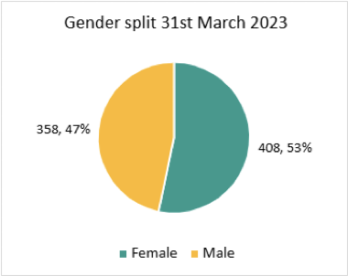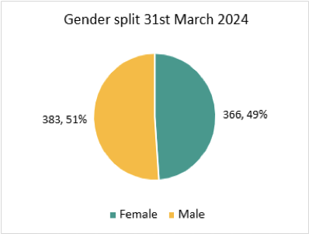

The graphs above indicate a decrease of 17 in the Whole Time Equivalent (WTE) compared to the 2023 gender pay gap report. In 2024, the organisation has shifted from a 47% female and 53% male workforce to a female establishment of 49% and a male establishment of 51%.

6. Ordinary Pay
The ordinary pay element is calculated after any salary sacrifice deductions are made, therefore lowering the actual pay. The gender split for such schemes will therefore affect the ordinary pay element. The table below shows a total of 43 staff members (34 male, 9 female) use the Salary Sacrifice Scheme. The percentage figures (Male and Female) show who uses the scheme compared to the to the organisation total (749).

Mean Gender Pay Gap
The ordinary pay percentage shows the difference between the mean average hourly rate of pay that male and female relevant employees receive.
The organisations mean gender pay gap is 9.87%.

Staff in organisation (749) | Male (34) |  | Female (9)
Salary Sacrifice Scheme | % of staff in scheme | % of staff | % of staff in scheme | % of staff
Cycle to Work Scheme | 32.35% (11/34) | 1.47% (11/749) | 22.22% (2/9) | 0.27% (2/749)
Lease Cars | 67.65% (23/34) | 3.07% (23/749) | 77.87% (7/9) | 0.93% (7/749)

Gender | Median Hourly Rate
Male | £13.45
Female | £12.59
Difference | £0.86
Pay Gap % | 6.39%

Median Gender Pay Gap

The calculation shows the difference
between the median hourly rate of
pay that male and female relevant
employees receive.

The organisations median gender
pay gap is 6.39%.

Gender | Avg. Bonus
Male | £897.82
Female | £605.51
Difference | £292.31
Pay Gap % | 32.56%

Mean Bonus Gender Pay Gap

The calculation shows the difference between
the mean bonus pay that male
and female full-pay relevant employees receive.

The organisations mean bonus gender
pay gap is 32.56%

Gender | Median Bonus Pay
Male | £1,000.00
Female | £533.34
Difference | £466.66
Pay Gap % | 46.67%

Median Bonus Gender Pay Gap

The calculation shows the difference between
the median bonus pay that male
and female relevant employees receive.

The organisations median bonus gender
pay gap is 46.67%.

7. Quartile pay bands
The proportion of male and female full-pay relevant employees in the equally sized lower, lower middle, upper middle, and upper quartile pay bands is as follows:

Quartile | Female | Male | Female % | Male %
1 Lower | 70.00 | 118.00 | 37.23 | 62.77
2 Lower Middle | 134.00 | 55.00 | 70.90 | 29.10
3 Upper Middle | 93.00 | 95.00 | 49.47 | 50.53
4 Upper | 71.00 | 118.00 | 37.57 | 62.43

The lower quartile represents our lowest paid staff, and the upper quartile represents our highest paid staff. The highest proportion of male employees per quartile is in the lowest and highest brackets whilst the lowest proportion is in the lower middle bracket which results in the gender pay gap of 9.87%.

8. Bonus Pay
The proportion of male and female employees who received these payments in the reference period are outlined below.

Gender | Employees Paid Bonus | % of staff paid bonus | Employees Not Paid Bonus | % | Total Relevant Employees
Female | 100 | 76.92% (100/130) | 266 | 72.68% (266/366) | 366
Male | 30 | 23.08% (30/130) | 353 | 92.17% (353/383) | 383

76.9% of female employees received a bonus payment in comparison to 23% of our male employees. Within this reference period the number of female employees receiving a bonus is higher than male employees.
The only element classed as bonus for the purposes of this report is the Estates and Facilities Directorate Performance Agreement.
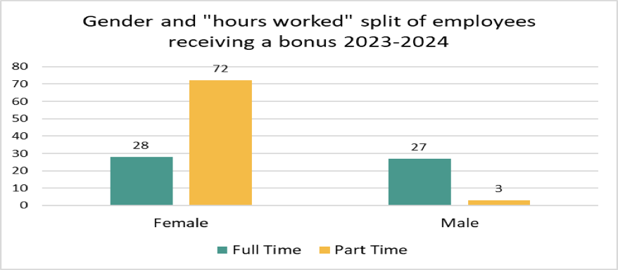

Note: Our long service awards are not included in the bonus calculations as they are a benefit in kind. We have a higher percentage of our female workforce working part-time in comparison to our male workforce.

9. Conclusion
The organisation has reduced the gender pay gap from 10.19% in 2023 to 9.87% in 2024. The organisation recognises the need for further action and notes the gender pay gap is not because people who are doing the same jobs are being paid differently according to their gender instead it is because there are more men than women in higher paid roles. Ensuring equitable access to development and training is indeed crucial for supporting the upwards transition of female staff. The organisation has identified actions to address the gender pay gap and ensure female staff have the opportunities and support they need to advance in their careers.
The organisation currently has a bonus pay gap of 32.56%. Departments eligible for the bonus scheme have paid bonus payments to a higher proportion of female than males. Specifically, 76.9% of female employees received a bonus payment compared to 23% of male employees. However, on average male employees receive a higher bonus payment than female employees. This discrepancy is not due to unequal pay for the same roles but rather the distribution of men and women across different pay levels.

10. Actions to reduce the pay and bonus gap

Monitoring and reviewing the pay gap is essential for identifying disparities and implementing strategies to reduce them. By regularly assessing the gender pay gap QE Facilities can, identify trends and disparities, developed targeted actions, ensure accountability, promote transparency and support career progression.

In support of providing a clear promotion route for female staff working at QE Facilities, during 2024 the organisation undertook a structural review to provide a clear promotion route for many female staff working in the facilities area. This change was part of a broader strategy to ensure equitable access to development and training in support of the upwards transition of female staff. During 2025 in support of further reduction of the gender pay gap QE Facilities will engage in the following actions.

- Ongoing Communication: Promoting awareness of the Equality, Diversity and Inclusion strategy is crucial for fostering and inclusive and equitable workforce. Regular updates and communications about the EDI strategy will be shared with all staff to ensure everyone is informed and engaged.

- Inclusive Recruitment Processes: Ensuring the organisation has inclusive recruitment processes that support diversity, and equality can help to attract and retain a diverse workforce. This can lead to a more balanced representation of men and women across different pay levels. The organisational change to provide clear promotion routes for female staff is part of a broader strategy to ensure equitable access to development and training. This structural review supports the upward transition of female staff, helping to close the gender pay gap

- Flexible Working Options: Developing flexible working options and workforce strategies to improve recruitment and retention of staff, including supporting female staff to return to work following maternity or adoption leave, can help to ensure that women have equal opportunities to advance in their careers.

- Career Progression Mechanisms: Reviewing mechanisms for career progression, staff development, and talent management to ensure equality and inclusivity within the process can help to support the upward transition of female staff. This can lead to a more balanced representation of men and women in higher-paid roles.

- Equitable Access to Development Training: By ensuring that all staff, particularly female employees, have access to development training, the organisation can support their upward transition and career progression. This helps to balance the representation of men and women in higher-paid roles, thereby reducing the gender pay gap

In April 2025 QE Facilities intends to implement a people strategy that will significantly influence the gender pay gap by addressing the root causes of pay disparities and promote equity within the organisation. By creating a strategy inclusive of the above actions QE Facilities will work towards reducing the gender pay gap and promoting equity within the organisation.

Statement
I confirm that QE Facilities is committed to the principle of gender pay equality and has prepared this report in line with mandatory requirements.
Name: Mr Gavin Evans
Job Title: QE Facilities Managing Director
Signature:
Date:
If you require a copy of this report in a different format, please contact the People and OD team at ghnt.peopleandodadmin@nhs.net

